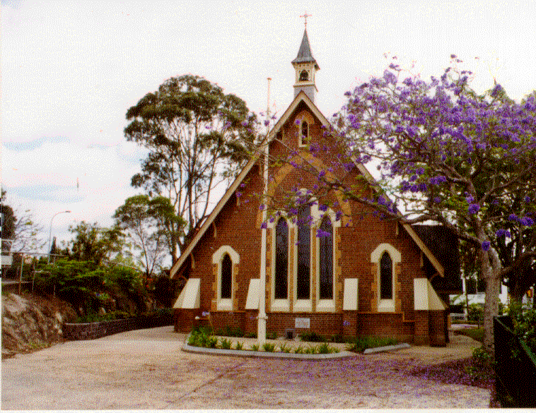

Wedding Information Booklet

St. Thomas’ Anglican Church, Toowong

RECTOR: THE REV’D TOM SULLIVAN

Cnr High & Jephson Sts
Address: 3/96 Jephson Street
Toowong QLD 4066

Phone: 0422 641 657
Website: www.stthomastoowong.org.au

Thank you for making enquiries about St. Thomas’ Anglican Church for your proposed wedding.

There are a number of things we would ask you to do so that we can confirm the date for you.

- Fill out the application form and return to the parish office. The form is found at the back of the booklet.

- Make an appointment with The Rev’d Tom Sullivan. This meeting should occur as soon as convenient to begin the process of preparation for the wedding. This is an opportunity to meet the priest and to discuss your individual needs and relationship. This meeting will include a mixture of an informal chat and some administrative tasks required for marriage.

- Obtain copies of your birth certificates (full originals) and bring them to your first meeting.

- The Anglican Church requires that one of you be baptised. Please confirm this on your form.

- Marriage Preparation Course is seen as an essential part of the preparation process and part of our professional and pastoral responsibility to you. We recommend Prepare / Enrich Marriage Education programs run by Anglicare Southern Queensland (www.BetterRelationships.org.au). These programmes are run by appointment and they have some after-hours times available as well. You can contact them directly on 1300 114 397. The cost of these programs is $200.

- As required by law, the Notice of Intended Marriage must be completed between one and six months before the marriage. Three months is our suggested time. The form is usually completed at the first meeting.

- The present cost of a wedding is $800. This includes the celebrant, use of the church, administration ($600) and organist ($200). See fees section for payment method.

- If you would like to use another celebrant:
- The celebrant must be an Anglican priest.
- You should make all arrangements through that person and ensure that they have requested permission to use the church.
- The fees would then be $550 and you would make your own arrangements to reimburse the celebrant.
- If you would like to include a priest/minister from another denomination could you confirm that this is acceptable to the Parish Priest and ask the celebrant to contact the Parish Priest six weeks before the wedding.

When your wedding date is confirmed
  - Please contact priest to discuss music.
  - Please contact Parish Office to confirm date.

If this is your second marriage
Because we take marriage seriously, the Anglican Church does not automatically marry divorced persons. It is necessary to ask the Archbishop’s permission. This is not a particularly onerous process, but tries to ensure that the marriage has every chance of success. It does mean that a six month lead up time is required so that permission is received before invitations are sent out.

Photographs
As a wedding is a religious ceremony at which important vows are made, we prefer photo taking to be discreet. Please discuss this with the priest. (If a video is being taken the photographer will be asked to remain in the same place throughout the service.)

Decorations
It is possible to attach decorations on the ends of the pews. The rehearsal is a good time to do this. Please ensure that someone is available to remove them immediately after the service so that the church can be closed without disrupting photos etc.

Parking
There is usually plenty of parking in the streets at weekends, and under the Parish Office (adjacent building to parish office).

Fees
The total fee for the wedding is $800.

Included in this fee is the use of the church, the celebrant, the organist and administration. Not included are fees associated with visiting Clergy or Ministers and the Marriage Preparation Course.

Please pay the fee no later than one month prior to the wedding to the Parish Office.

Please complete your fees form below.
ST THOMAS’ ANGLICAN CHURCH
3/96 Jephson Street, Toowong, QLD 4066
Names: _________________________________________

Date of Wedding: ______ / ______ / ______ Time:______________

Enclosed is a cheque for $ _______________, being fees for our
wedding. Cheques may be made out to St Thomas’ Anglican Church.

Alternatively, payment by Credit Card:

❒ Visa  Mastercard  Bankcard

Amount: $
Name on Card:
Card No:
CVC:
Expiry Date:

Signature: ___________________________________

Alternatively, if you would like to pay via electronic funds transfer, our bank account details
are listed below:

Bank: ANFIN
Name: Toowong Anglican Parish Overdraft
BSB: 704901
Acc No: 00004710

Please note in the reference area of the transaction:
Wedding / {your surname}

APPLICATION TO BE MARRIED

Date of wedding
Time of wedding
 | Groom | Bride
Surname

Given Names
Home phone
Mobile
Work phone
Personal email address

Name of witness
(bestman)

Name of witness
(bridesmaid/maid of honour)

Usual occupation

Full Address

Conjugal status eg. Never validly married, divorced, widower, widow.
Birthplace (if born in Australian: city or town and State. If born outside Australia: city or town and country).
Date of Birth | date/month/year | date/month/year
Father’s name in full (If not known, write “unknown”. If deceased, add “deceased”)

Father’s country of birth
(If not known, write “unknown”)

Mother’s maiden name in full (If not known, write “unknown”. If deceased, add “deceased”)

Mother’s country of birth
(If not known, write “unknown”)

Baptism details
(Date and Place)

In which denomination were you baptised?

GENERAL
Is an organist required? Yes/No
DATA 3 carpark is available in the evenings and weekends

